ENG200010 Engineering Technology Design Project  
Individual Report

Dang Khoa Le

Student ID: 103844421  
Major: Bachelor of Software Engineering

Group 3 – Workshop Wednesday 4.30 PM

**Group 3 Members:**

Zach Smith – 102573986

Dang Khoa Le - 103844421

Jhilam Roy - 103515840

Mohammad Safayetul Hoque Chowdhury – 103806201

Abstract - **This document presenting the Individual Report, which will report, discuss, and evaluate the learning outcomes achieved in the project. This is an individual report, and it will include evidence and reflection that demonstrates the achievement of the unit learning outcomes. It will also discuss the outcomes of my project and the design fundamentals applied in the project. The report will include details from the evaluations conducted in testing and include the design solution or model. The report will also highlight my individual contribution to the project with simulation and test results and include the response to the feedback provided on the design brief and during the project demonstration and presentation.**

Appendix A: Technical Log

*I. Executive Summary:*

This comprehensive project report encapsulates the design and successful execution of the group project and the ground-breaking "Rail Level Crossing Automation System" (RLCAS). This innovative system leverages automated technology and cutting-edge methodologies to revolutionize traffic management, ensuring the safety and convenience of road users and railway operators. The RLCAS project has introduced an independent and fully automated rail level crossing system, incorporating Ni-DAQ technology, a system of LEDs, Servo motors and IR sensors. These components are seamlessly controlled through the central LabVIEW interface, representing a significant upgrade over traditional (manual) rail level crossing systems.

This project report also evaluating individual study progression within this unit. It reflects on the learning outcomes achieved during the course, highlighting personal contributions to the group project, accomplishments, and reflective learning experiences.

*II. Table of Content:*

Table of Contents

Appendix A: Technical Log 1

I. Executive Summary: 1

II. Table of Content: 2

III. Introduction: 3

**1.** **Project Motivations** 3

a. Background: 3

b. Milestones: 3

**2.** **Project Scope** 3

**3.** **Project Description** 4

**4.** **Hardware and Software Concept** 4

**5.** **Train Concept** 5

IV. Individual Contribution: 5

**1.** **To the Project Brief** 5

**2.** **To the Project Concept** 5

**3.** **Reflections to the Unit Learning Outcomes (ULOs)** 6

V. Reflections: 7

**1.** **Methods** 7

a. Train detection software: 8

b. Train waiting: 8

c. Vehicle traffic flow (decreasement): 9

**2.** **Technical Learning** 9

Appendix B: Teamwork Breakdown 10

I. Project Outcomes: 10

**1.** **Success** 10

**2.** **Constraints** 10

**3.** **Timeline** 11

II. Duties Breakdown: 11

III. Conclusions: 11

IV. Project Reflections: 12

*III. Introduction:*

1. **Project Motivations**

Rail level crossings represent essential intersections in transportation networks, where roads intersect with railways. These intersections play a vital role in ensuring efficient and safe transportation. However, their critical role in ensuring safety necessitates a paramount focus on operational reliability. Manual management of these crossings has been fundamental with inherent challenges, such as safety hazards, traffic congestion, and operational inefficiencies. These challenges and the need for enhanced safety and efficiency serve as the foundational motivations for the RLCAS project.

1. Background:

* This design aims to enhance traffic flow, mitigate congestion, and contribute to the broader traffic management system for the benefit of the community and local commuters.​
* The level crossing is extremely congested during rush hours, resulting in backups that stretch to the off-ramp from the adjoining motorway.​
* RLCAS proposal includes several key components like Advanced traffic management, Smart Railway Scheduling, Sustainable infrastructure, Traffic Pattern Analysis.​
* The design concept represents a level crossing halfway between 2 stations that are 3km apart from each other.

1. Milestones:

* RLCAS aims to ensure a significant reduction in accidents, fatalities, and injuries related to level crossings by implementing advanced safety measures.​
* RLCAS can ensure the cost effectiveness and viability, which is vital for the project management.
* Conduct a comprehensive evaluation of the implemented system's performance, focusing on traffic flow improvement, safety, and community feedback.

1. **Project Scope**

The scope of this project encompasses a set of core objectives that collectively contribute to a safer and more efficient transportation ecosystem, compared to the traditional rail level crossing systems, which consist of numerous disadvantages:

* **Enhancing Traffic Safety:** The principal objective of the RLCAS is to raise the bar on safety at rail level crossings. The system achieves this by reliably and accurately detecting the presence of approaching trains and efficiently managing the lowering and raising of barriers and warning signals.
* **Mitigating Traffic Congestion:** Automation of rail level crossings is a significant step towards alleviating one of the primary sources of traffic congestion. By reducing waiting times, optimizing traffic flow, and minimizing the risk of traffic jams, the RLCAS enhances transportation efficiency.
* **Consistency and Reliability:** Automation brings unmatched consistency to the operation of rail level crossings. Each passage of a train is managed with pinpoint precision. The system is designed to operate continuously, undeterred by external factors, such as adverse weather conditions or time of day.
* **Public Safety:** Rail level crossings are often strategically situated in densely populated areas. The operation and safety of these crossings affect pedestrians, cyclists, and drivers. The RLCAS guarantees the safety of all users and the consistent and reliable operation of crossings.
* **Efficient Operation:** Beyond safety, the RLCAS enhances operational efficiency. The system ensures that train crossings occur with minimal disruption to road traffic. Its continuous operation guarantees that rail level crossings remain safe and functional, irrespective of external conditions.

1. **Project Description**

This project centres on the development and implementation of the Rail Level Crossing Automation System (RLCAS). RLCAS is an innovative solution that revolutionizes rail level crossing management using automation technology. The project integrates various components, including IR sensors, Servo Motors, LEDs, LabVIEW interface, and the NI-DAQ system to ensure the safety and efficiency of road users and railway operators. The project addresses the need for enhanced traffic safety, reduced congestion, and consistent railway operations. Through systematic design, problem-solving, and technical expertise, RLCAS aims to improve transportation safety and convenience.

1. **Hardware and Software Concept**

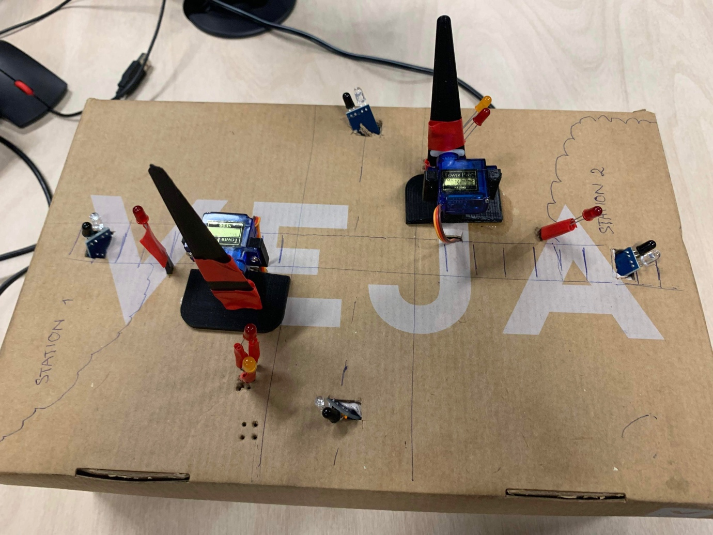 The design concept encompasses the following hardware and software implementations, which constructed an effective architecture for the project with methodical logics:

Figure. RLCAS hardware components

* **IR Sensor Configuration**: The system employs 4 strategically positioned IR sensors. These sensors will be evenly distributed, with 2 sensors located at each end of the railway tracks and 2 allocated at each side of the road intersection. These sensors will collectively detect the presence of approaching trains and the availability of awaiting vehicles.
* **Servo Motor Operation:** The level crossing barriers will be controlled through the operation of Servo Motors. These 2 motors will be responsible for both lowering and raising the barriers as signalled.
* **Warning LED Deployment:** The system will incorporate two prominent red warning LEDs, placed on either side of the road intersection. These LEDs will activate upon the approach of a train, indicating that the level crossing barriers are in the lowered position.
* **LabVIEW Interface:** LabVIEW will serve as the central interface for system control and monitoring. The execution interface will enable efficient management of the entire system.
* **NI-DAQ Integration:** The Ni-DAQ interface will facilitate the communication between LabVIEW and the hardware components. This integration ensures the coordinated operation of sensors, motors, and warning LED lights, optimizing system performance and responsiveness.

1. **Train Concept**

Considering the distance between 2 station (2 sensors) to be 3 kilometres in real life, however in this architectural concept the design is scaled it down by a factor of 6​:

* The distance has scaled down to represent 500m which the train has 36 seconds to cover from when it reaches the station.​
* When there is normal traffic load the train takes 36s.​ -> Train speed v = s/t = 500/36 = 13 m/s or 50 km/h.​
* When there is a busy traffic load the train takes 24s​ -> Train speed v = s/t = 500/24 = 20 m/s or 75 km/h.​
* At "busy traffic", the train can wait up to 12 seconds​.
* At "busy traffic", the train (which is automatically operated will change it speed accordingly to the state).

When the train finished 35% of its journey (either at "busy traffic" or not), the boom gate will be closed down, amber traffic lights present beforehand for 1 seconds beforehand to inform traffic users to slow down then turns red alongside with the boom gate down, to stop the traffic flow and allow train go through the intersection safely; the boom gate will open up and red light turns off once when the train passes it's 65% of the journey to allows traffic flow again (the train progression is based on the time once it departs from the station).

*IV. Individual Contribution:*

1. **To the Project Brief**

Within the context of the Project Brief, my task responsibilities consist of outlining the Project Overview, the Project Objectives and Scope, defining Project Specifications, and summarizing the Conclusions.

1. **To the Project Concept**

Within the context of the Project Concept, my individual contribution consist of constructing numerous sustainable and logical designs (hardware, software and demonstration), which serve a fundamental role in this architecture project concept. My task encompasses the following tasks (also indicated in the Project Breakdown):

* Train detection software
* Train's waiting system (based on traffic)
* Vehicle traffic flow system (traffic count decreasement)
* Prototype Construction
* Train Concept

More precisely, my contributions encompass the development of multiple software systems, in order to detecting approaching trains and calculating their waiting times based on real-time traffic conditions. I also actively participated in crafting a realistic traffic flow simulation, made substantial contributions to the hardware construction, and the comprehensive prototype construction within the LabVIEW codebase, I also collaborated with Zach in establishing the mathematical principles governing train speed, timing, and the corresponding waiting periods.

1. **Reflections to the Unit Learning Outcomes (ULOs)**

In this section, I'll reflect on how my contributions to the project align with the Unit Learning Outcomes (ULOs).

**ULO1: Apply a systematic approach to engineering technology design**

In the context of this project, applying a systematic approach to engineering technology design was fundamental to creating a reliable and efficient rail level crossing automation system. My contributions in this area extended beyond the initial design to the ongoing development and refinement of various components.

* Train Detection Logic: Developed a structured logic for accurate train detection and timely boom gate operation.
* Train Waiting Management: Created a systematic approach to manage traffic flow, hence calculating waiting times methodically for trains during heavy (busy) traffic conditions.
* Traffic Count Reduction: Implemented a systematic process to update traffic counts in real-time, aiding traffic management more realistically.
* Software-Hardware Integration: Established systematic communication protocols between LabVIEW and hardware components, ensuring seamless system operation.

In each of these examples, a systematic approach was essential to ensure that design elements worked coherently and predictably. It prevented errors, inconsistencies, and unexpected behaviours that could compromise the safety and efficiency of the rail level crossing system. Furthermore, this systematic approach adhered to established engineering design principles, emphasizing the importance of reliability and precision in technology systems.

**ULO2: Apply knowledge of design fundamentals to engineering technology challenges**

Throughout the project, I applied fundamental design principles to address complex engineering challenges. The creation of software for train detection, train waiting, and traffic management was founded on a deep understanding of how to design robust, efficient, and reliable systems. This knowledge enabled me to develop solutions that met the project's objectives and contributed to the successful execution of the rail level crossing automation system (RLCAS).

**ULO3: Find, organize, and make decisions on a range of topics related to engineering technology design**

My work on this project involved finding, organizing, and making decisions on various topics related to engineering technology design. This encompassed not only seeking resources online but also optimizing the design's logics and methods. For instance, I organized and processed information on train detection, traffic flow management, and waiting time calculations. I made informed decisions on the logic and algorithms governing these systems, directly influencing the design and functionality of the rail level crossing automation system. This experience enhanced my ability to efficiently navigate and make decisions on a wide range of engineering technology-related topics.

**ULO4: Use engineering technology to develop and present design solutions**

I effectively used engineering technology, including LabVIEW application, sensor, LEDs and motors technologies, to develop practical design solutions. These solutions encompassed train detection, waiting time calculations, and traffic flow management, which were instrumental in creating a fully automated rail level crossing system, by simulating an actual railway intersection. The integration of hardware and software components facilitated the development of a coherent and functional design solution.

**ULO5: Demonstrate reflective practice and use self and peer evaluation**

Reflection was an integral part of the project, and I continually demanded myself to construct reliable and effective designs. This involved ongoing reviews and improvements to my contributions, aimed at enhancing the performance and reliability of the systems I developed. Moreover, since the project's inception, open discussions with peers regarding their individual tasks were conducted, ensuring that everyone was thoroughly familiar with their respective topics. This reflective practice and the engagement in peer evaluation significantly contributed to the overall success of the project. It created a collaborative environment that encouraged peer input, leading to better-designed solutions and reinforcing the importance of reflective practice in project development.

**ULO6: Communicate within teams and stakeholders using appropriate verbal, written, and technological approaches**

Effective communication within the project team was vital. I actively communicated with team members to ensure that our contributions were integrated seamlessly. I also employed written and technological approaches, particularly in the software design, to create clear and comprehensible solutions for the project. Additionally, I collaborated with my peers, including Mohammad, Jhilam and especially, Zach, and organising team meetings among us at least twice a week either at campus or via video calls. We also have a group chat to allow members sharing their opinion and get updates from others daily, ensuring everyone keeping up be able to maintain the coherence and efficiency for the entire RLCAS project. Peers also encouraged to actively participate and contribute their works towards the RLCAS project, asking questions and support others to work effective as a team member.

In summary, my contributions to this project align closely with all of the Unit Learning Outcomes (ULOs). I applied a systematic approach to engineering technology design, used design fundamentals to address challenges, organized and made informed decisions, utilized engineering technology to develop solutions, demonstrated reflective practice, and effectively communicated within the project team. These experiences have significantly contributed to my understanding of engineering technology and the practical application of design principles in complex projects, which will facilitate me a good resource for my academic and future career.

*V. Reflections:*

1. **Methods**

The project leveraged LabVIEW and the NI-DAQ interface, allowing for precise control of IR sensors, Servo Motors, and LEDs. Logic was employed to ensure accurate barrier operations based on train detection, simulation and traffic conditions.

1. Train detection software:

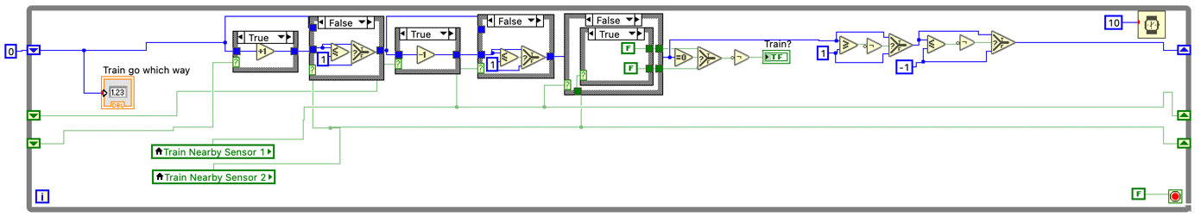I created a system that detects train when nearby to the boom gate, in either directions. This system effectively lowers the level crossing (boom gate) when the train completes 35% of its journey, raising it once the train reaches 65% of its journey.

Figure. Train Detection While Loop

The LabVIEW diagram above illustrating how the train detection software works. It employs a numeric variable called "Train go which way", which trains departing from the left (station 1) increase this variable by '1', while those departing from the right (station 2) decrease it by '1'. If the numeric variable deviates from zero, it indicates the presence of a train. This information is recorded in the local boolean variable "Train?," which controls the movement of the boom gate, allowing it to be raised or lowered..​

Additionally, a function was designed to check whether the "Train go which way" variable falls below '-1' or exceeds '1'. In such cases, the function ensures that the numerical value remains within the acceptable range (between -1 to 1), preventing systematic errors, such as duplicated sensor triggers, which could disrupt the logical sequence and result in inconsistent system operation.

It's important to note that any changes to the boom gate are exclusively initiated when the train is in close proximity to the gate (approximately 65% of its journey). This is regulated by two boolean variables "Train Nearby Sensor 1" and "Train Nearby Sensor 2". These variables store their values in shift registers and allow the "Train go which way" numeric variable to progress through the system of case structures only when either of the boolean variables is set to 'true' (but not both simultaneously).

When the train reaches it 65% of the journey, which simulates the train has successfully left the intersection, “Train go which way” numerical variable is reset back to ‘0’ and “Train?” boolean value returns to ‘false’.

1. A screenshot of a computer

   Description automatically generatedTrain waiting:

Once when a train presented at a station (train sensor is detected), "Observe traffic" boolean value turns true, which control a case that makes the train to wait for the busy traffic flows to alleviate. The waiting time is based on the “Add wait time” local numerical variable. ​If there is no “Busy traffic”, the train can depart the station immediately without waiting.

Figure. Train Waiting While Loop

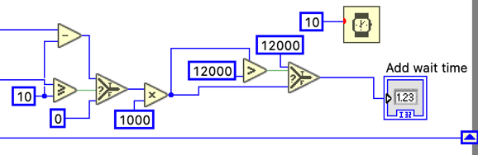In regards with the traffic increasement (by Zach), for every passing vehicle detected by any of the two IR sensors, the numerical variable "Traffic Count" increases by one. Once the "Traffic Count" reaches or surpasses 10, the boolean variable classifies the traffic condition as "Busy traffic," simulating a state of heavy traffic congestion. In the "Busy traffic" scenario, trains waiting at the station are forced to delay their departure until the " Add wait time" duration elapses.

In response to escalating traffic loads, each vehicle exceeding the threshold of 10 (vehicles) incrementally adds one second (1000 ms) to the train's waiting time. This controlled waiting time adjustment, up to a maximum of 12 seconds (12000 ms), ensures that traffic loads do not excessively impede the timely operation of the public railway services.

Figure. Add Wait Time Algorithm

For example, if the traffic load reaches 14 vehicles, the train is required to wait an additional 4 seconds before departing from the station. Meanwhile, where traffic loads reaches 24 vehicles, the system just imposes a 12 seconds waiting period as the maximum "waiting time" to expedite the alleviation of traffic congestion.

1. Vehicle traffic flow (decreasement):

The "Traffic Count" variable is subject to gradual reduction. This decrement occurs at a rate of one per second, effectively simulating the exit of a vehicle from the intersection. This reduction in the traffic count variable only transpires when the boom gate is raised (“Train?” value is false), allowing traffic to flow seamlessly. This dynamic feature ensures that the system maintains a real-time and accurate representation of the traffic load.

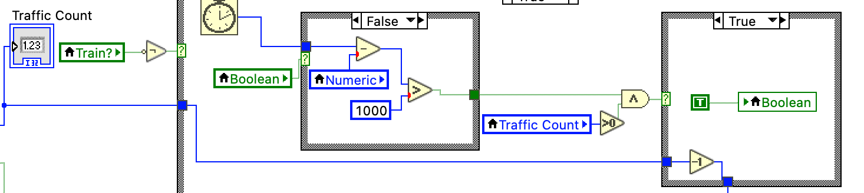In the LabVIEW diagram above, a ‘Wait (ms)’ function is implemented and will gradually count up time in milliseconds (ms), at which if it exceed 1000 ms, the timer will be reset. Each time when this timer is reset and the “Traffic Count” is greater than ‘0’, the “Traffic Count” variable will be deducted by ‘1’, simulates the traffic flow at the station.

Figure. Vehicle Decreasement Algorithm

1. **Technical Learning**

Via this project, I delved deeply into sensor technologies and their real-world applications. Understanding how to precisely detect the presence of an approaching train was a significant challenge that required comprehensive learning. This learning process encompassed the study of sensor types, their data collection methods, and how to translate sensor inputs into actionable responses for the rail level crossing automation system.

The use of LabVIEW as the central software platform for system control was equally enlightening. I explored the intricacies of this powerful software, delving into programming logic, data visualization, and communication with hardware components. Besides, students also got to learn how to create a cohesive system where software, including the LabVIEW interface, effectively communicated with the hardware components, ensuring the reliable operation of the rail level crossing system.

Moreover, I gained proficiency in software development for practical engineering applications. Hence, I encapsulate my skills in logical thinking, algorithm design, and coding. This technical learning has provided a solid foundation for future projects in engineering and technology-related topics. It has expanded my capacity to approach complex problems systematically and develop innovative solutions using powerful technologies.

**Appendix B: Teamwork Breakdown**

*I. Project Outcomes:*

1. **Success**

The RLCAS project stands as a testament to what can be achieved through innovation, teamwork, and a steadfast commitment to safety and efficiency. The amalgamation of a successful technology, collaborative efforts, and an unwavering dedication to enhancing safety and efficiency positions the project for unmitigated success.

1. **Constraints**

The project constraints shaped within the project's trajectory and demanded creative problem-solving:

**Resource Limitations:** One of the primary constraints was the availability of resources. We had to work within a limited resources of both hardware and the lack of software information in LabVIEW (when developing a higher level logics). This constraint forced us to seek for all supportive and alternative solutions online, while optimize our use of any available resources, components given.

**Time Pressure:** The project operated on a strict timeline, which presented time pressure for design, development, and testing. We had to make efficient use of our time to meet project milestones, and this occasionally limited our ability to explore more elaborate design options.

**Hardware Compatibility:** Integrating various hardware components was a complex task. Ensuring compatibility and effective communication between the LabVIEW interface and the hardware components presented challenges that we needed to address. This constraint required careful testing and debugging to ensure smooth system operation.

**Complex Software Logic:** Designing the software logic for train detection, waiting, and traffic management was intricate. It required a deep understanding of traffic patterns, train movements, and real-time adjustments. This complexity posed a challenge in terms of programming and system optimization.

In light of these constraints, our team focused on creative problem-solving, efficient resource allocation, and rigorous testing. Overcoming these challenges not only facilitating our technical knowledge but also taught us the value of adaptability and innovation in engineering projects. We emerged from this experience with a deeper understanding of the practical intricacies involved in transforming innovative concepts into functional, real-world solutions.

1. **Timeline**

The first 6 weeks was majorly spent to ensure all members have a chance to finalise their individual assignments, however, we also used this time to build up a good relationship across team members and allow us to have some time to investigate and get to know deeply about LabVIEW and other fundamental engineering technologies in this unit (e.g., hardware, Ni-DAQ, etc). Hence, we started working on RLCAS project from week 7, below is our table of timeliness.

|  |  |
| --- | --- |
| **Week number** | **Progression** |
| Week 7 | Planning the design for the level crossing management scheme. |
| Week 8 | Finalising the design after making minor changes. |
| Week 9 | Creating a draft of the design. |
| Week 10 | Individually working on the specified parts assigned to each member. |
| Week 11 | Working together to put every member’s part into the design. |
| Week 12 | Testing the design and presenting it. |

*II. Duties Breakdown:*

The following table indicating each member of the group’s tasks division (duties breakdown), the table indicate specifically whom do which part.

|  |  |
| --- | --- |
| **Team Member** | **Duties** |
| Zach | Train progression  Train's waiting system  Vehicle traffic flow system (traffic count increasement)  Train stopping light (LEDs)  Prototype Construction  3D printing (including the hardware)  Train Concept |
| Khoa Le | Train detection software Train's waiting system  Vehicle traffic flow system (traffic count decreasement)  Prototype Construction  Train Concept |
| Jhilam | Boom Gates  Prototype Construction |
| Mohammad | Traffic light system (LEDs)  Prototype Construction |

*III. Conclusions:*

In conclusion, our system's automation of barrier operations and the provision of clear warning signals represent substantial strides towards reducing accident risks and enhancing transportation safety. Despite the formidable constraints inherent in the project's design concept and the challenges associated with real-world implementation, our project team is unwavering in its commitment to delivering this essential safety solution with reliability and diligence.

By utilizing IR sensors, Servo Motors, LEDs, LabVIEW integration, and the NI-DAQ interface, we have created a robust and efficient system that can be deployed at a real-world application rail crossings to reduce the risk of accidents and improve transportation safety. This innovative solution not only streamlines rail level crossing management but also contributes significantly to the well-being of road users and the operational efficiency of train services. The successful execution of this project exemplifies our dedication to safety and our ability to leverage technology for the betterment of transportation networks.

Looking ahead, the possibilities for this Rail Level Crossing Automation System (RLCAS) are very potential. The successful development of this automated system opens the door to scaling it up for real-world deployment. One natural progression would involve integrating additional sensors, allowing for even more precise train detection and monitoring of complex vehicular traffic scenarios.

Moreover, in future developments, there is an exciting potential to integrate advanced predictive analytics, possibly leveraging machine learning algorithms to enhance the accuracy of traffic load forecasts and train schedules. This is particularly relevant because traffic patterns typically exhibit variations throughout the day, with distinct peak periods, often coinciding with the rush hours when commuters travel to and from work. Such enhancements wouldn't only bolster safety but would also significantly improve traffic management, leading to reduced travel times and alleviating congestion.

Additionally, for scalability and integration into broader transportation networks, considerations should be made for connectivity and data sharing with other intelligent transportation systems. The RLCAS can become an integral part of the evolving smart city infrastructure, enhancing the overall quality of life for commuters of either train and individual vehicles, while setting new standards for safety and efficiency in railway and road transportation. This project is able to successfully deliver a safer, more efficient, and highly automated transportation systems, while it can also be a start of many innovative designs using its pattern and architecture, to even extend the users’ experience beyond.

*IV. Project Reflections:*

1. **Design Changes and Developments:**

Several iterations were made in the design concept, posing challenges that pushed the team to seek improved approaches.

The initial concept aimed to create an automated system that would lower the boom gate when a train was detected by any sensor, ensuring traffic user safety until the train completely passed the intersection. At that point, both sensors directly controlled case structures instead of using local boolean variables like "Train nearby Sensor." However, this design proved ineffective, prompting revisions.

A subsequent design involved creating a train detection system that relied on time-based waiting once a train was detected (leaving a station). While serving as a fundamental foundation for later design patterns, this approach was found to be ineffective and incapable of integrating traffic conditions.

The current project design efficiently fulfills all the criteria and demands discussed during our team meetings.

1. **Testing, Debugging, and Results:**

Testing was a crucial step in the development process. Meetings provided the opportunity for all members to integrate their work into a cohesive architecture. However, due to occasional misunderstandings about the software patterns employed by team members, direct testing became essential to make effective alterations and resolve encountered errors. In my section, the "traffic count" (increasement) portion by Zach experienced numerous issues that affected my "train wait time" section, leading to time-consuming testing and debugging. Similarly, my "train detection software" revealed multiple errors that required ongoing fixes, ultimately leading to the development of the final design.

1. **Data Measurements and Simulations:**

Data measurements were collected from the sensors and simulated in LabVIEW using logical methods. While my role focused on collecting data from the train sensor and Zach's role involved traffic sensor data collection, the train sensor detection data was found to be accurately measured. Nonetheless, alterations were made in the way this data was simulated, particularly in the transition from the initial "direct detection - data execution" approach to the more reasonable "train progression protocol."

1. **Technical Problems and Solutions:**

Throughout the project, various technical issues were encountered, and systematic debugging and troubleshooting were applied to find solutions. These problems included:

**Integration Challenges:** One notable challenge was integrating different software components created by team members. The diverse coding styles and logic sometimes led to conflicts and inconsistencies.

**Solution:** To resolve integration issues, regular testing sessions were held where team members reviewed and tested each other's work. These sessions helped identify conflicts and discrepancies, leading to collaborative solutions. Moreover, a coding style guide was developed to maintain consistency across different sections of the project.

**Traffic Count Accuracy:** Achieving accurate traffic count data from sensors was crucial for realistic simulations.

**Solution:** We fine-tuned the traffic sensor data collection and processing logic to ensure accurate and reliable traffic count measurements. This involved adjusting the sensor sensitivity, processing algorithms, and the way traffic flow was simulated.

**Train Detection Reliability:** Ensuring that the system accurately detected trains approaching the level crossing was essential for safety.

**Solution:** We implemented a redundancy check mechanism that required both train sensors to detect the train's presence before activating the boom gate. This significantly improved the reliability of the train detection system.

1. **Meetings and Discussions:**

Team meetings played a pivotal role in this project. They were conducted on weekdays and occasionally on weekends, either in person at the campus LateLab or virtually via Microsoft Teams. Additionally, we had workshops on Wednesdays and team meetings with our facilitator on Mondays too.

During these meetings, team members were tasked with presenting their work for discussion. These sessions facilitated extensive discussions and idea exchanges, leading to innovative design pattern changes that were gradually implemented, finalizing the project's architecture. Effective communication and collaboration during these meetings were instrumental in achieving the project's success.